Note: Kindly run this on chrome for intended output.

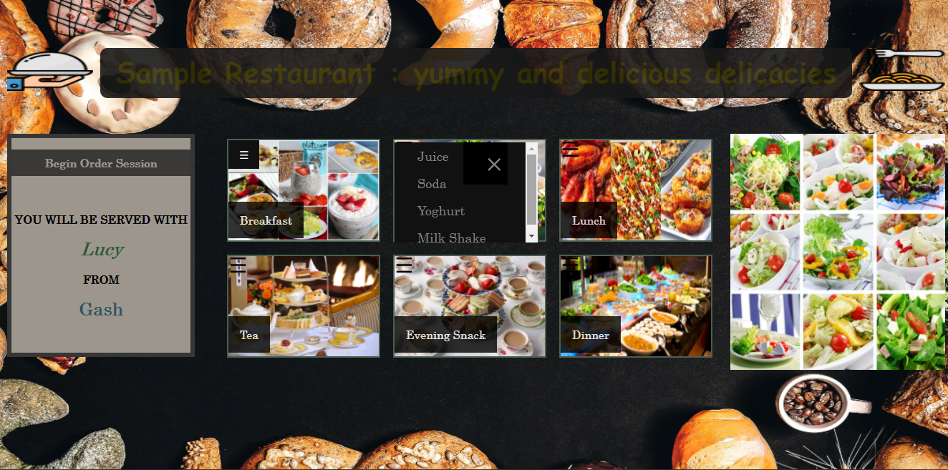

On this site, functionality is only set on slide 2, on the first item, Juice.

When you hover on juice, a dropdown list will appear, which allows the waiter to input the number of glasses/bottles of juice a customer wants. Juice inventory is set to 30 bottles for demo. If a user orders lets say 4 bottles, the new amount will be 26 on the database.

